
Linux Commands

- ls

Lists files and directories in the current directory.

- pwd

Shows the present working directory (current location).

- dir

Also lists files and directories (alternative to ls).

- touch

Creates an empty file or updates file timestamp.

- nano

Opens a file in the nano text editor.
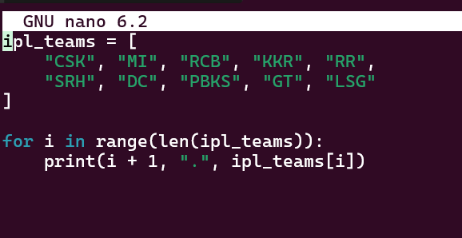

- cat

Displays file content on the terminal.
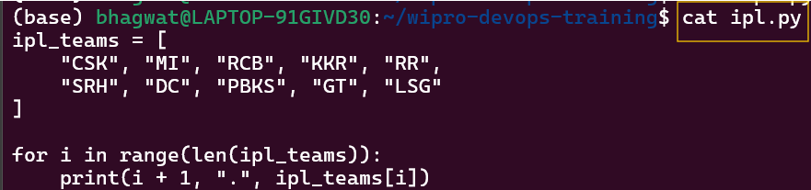

- cd . .

Moves one directory back (parent directory).

- mkdir

Creates a new directory.
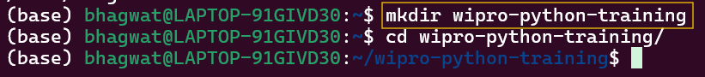

- whoami

Displays the current logged-in user.

- mv

Moves or renames files/directories.

- rmdir

Deletes an empty directory.
- rm -rf

Deletes files or directories forcefully and recursively.

- cd ../..

Moves two directories back (up) from the current directory.

- cp

Copies files or directories from one location to another.
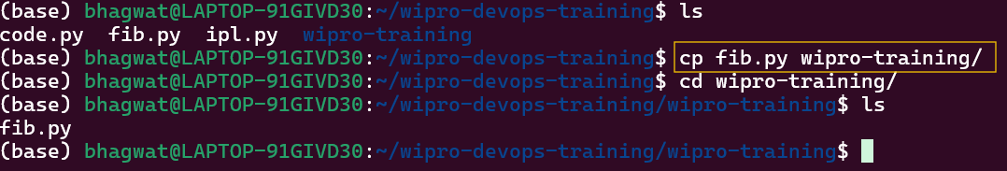

- mv ..

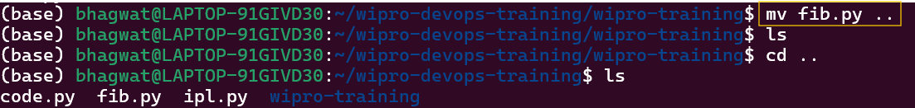

- wget <URL>

Downloads a file from the internet.
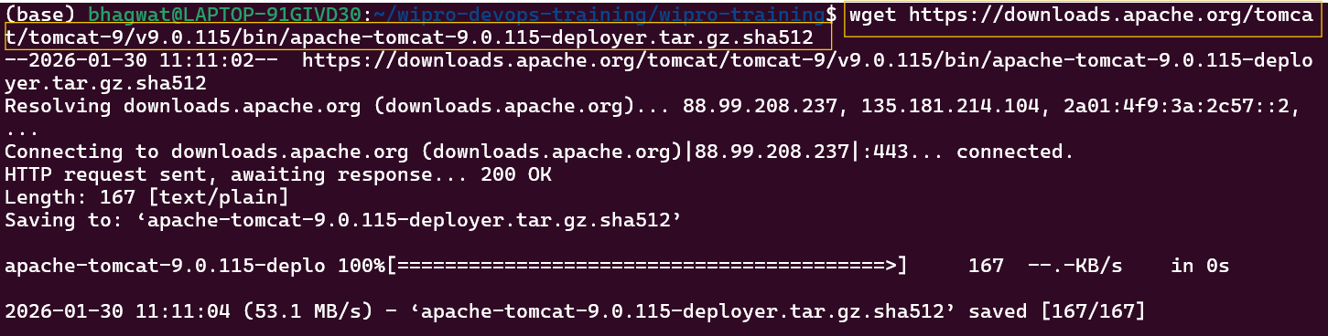

- ping

Checks network connectivity
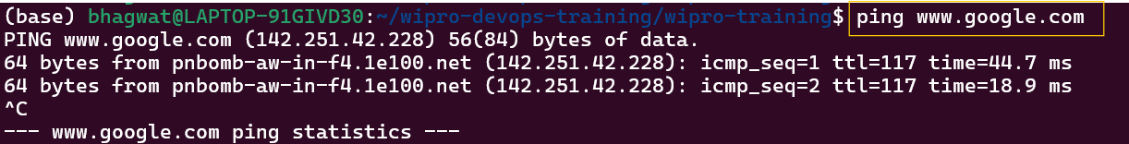

- History

Displays all previously executed commands.
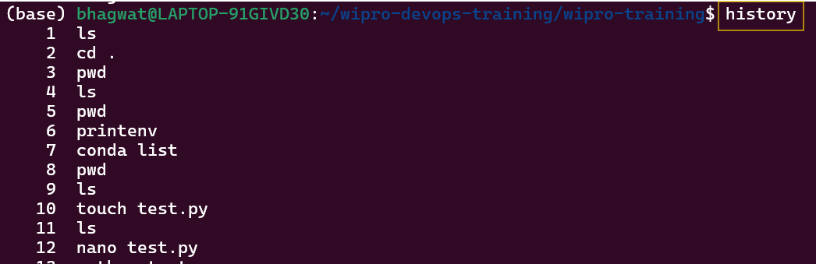

- df

Displays disk space usage of all mounted filesystems.
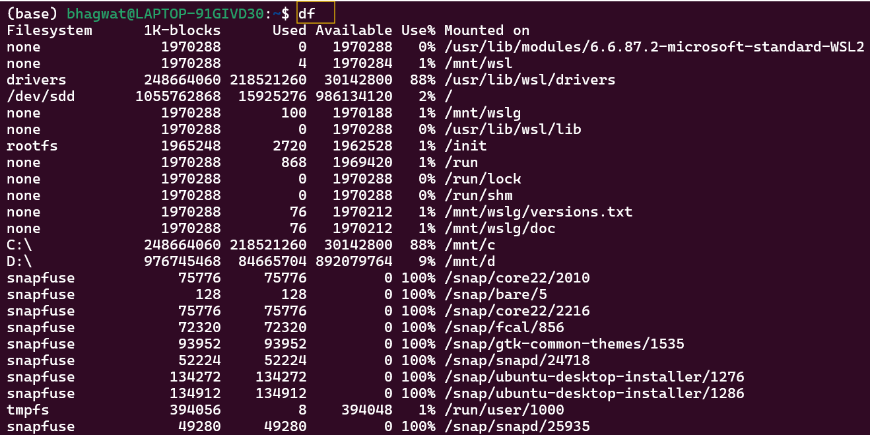

- fcal

Displays a calendar.
